* Create a one-page infographic that outlines the SDLC phases (Requirements, Design, Implementation, Testing, Deployment), highlighting the importance of each phase and how they interconnect.

**Software Development Life Cycle (SDLC) Phases**

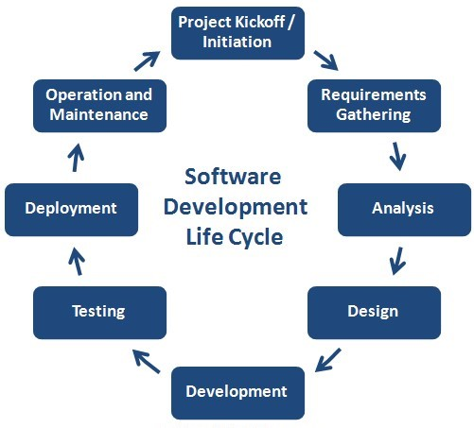

**1. Requirements**

* **Importance:** Identifying and documenting the needs and expectations of stakeholders.
* **Interconnection:** Foundation of the entire development process, informing subsequent phases.

**2. Design**

* **Importance:** Translating requirements into a blueprint for development.
* **Interconnection:** Bridges the gap between requirements and implementation, ensuring alignment with stakeholders' expectations.

**3. Implementation**

* **Importance:** Transforming design into executable code.
* **Interconnection:** Directly influenced by design, ensuring that the developed software aligns with the planned structure and functionalities.

**4. Testing**

* **Importance:** Evaluating software for defects, bugs, and adherence to requirements.
* **Interconnection:** Validates whether the implemented software meets the specified requirements and design standards, facilitating quality assurance.

**5. Deployment**

* **Importance:** Releasing the software for its intended users.
* **Interconnection:** Culmination of the SDLC, integrating all previous phases' efforts to deliver a functional product to stakeholders.

**Conclusion**

The SDLC phases are interconnected stages crucial for delivering high-quality software that meets stakeholder expectations. Each phase builds upon the preceding one, emphasizing collaboration and iteration to ensure successful software development and deployment.